HUMAN FOLLOWING ROBOT USING ARDUINO
🔹 Introduction 🔹
Robotics is a rapidly growing field that merges mechanics, electronics, and computing to enable machines to perform tasks autonomously or in collaboration with humans. Among the many applications of robotics, human-following robots hold a special place due to their ability to aid, guide, or carry items alongside a person. This makes them especially useful in service, healthcare, education, and industrial settings.
The human-following robot is designed to track and follow a person’s movement while avoiding obstacles. This kind of robot can be a helpful assistant — for instance, following a caregiver to carry heavy loads, delivering food or medication, or acting as a guide for tourists in a hotel or museum. The robot maintains a specified distance from its human counterpart and continually adjusts its trajectory in real time, adding a degree of adaptability and safety.

🔹 Brief Overview 🔹
This project involves designing and building a robot that follows a human by employing ultrasonic and infrared sensors alongside a microcontroller (Arduino). The main components include:
- Arduino Uno (microcontroller) — acting as the robot’s “brain”.
- Ultrasonic sensor (HC-SR04) — used to measure the distance to the person in front.
- Infrared sensors (IR modules) — used to track the direction of the person.
- Servo motor — for panning the ultrasonic sensor left and right, extending its range of view.
- Motor driver (L293D or motor shield) — controls the DC motors’ forward, backward, and turning movements.
- Li-ion battery pack — provides power for the robot’s operation.
The robot operates by constantly scanning its environment with the ultrasonic sensor while interpreting signals from the infrared sensors. Based on this data, the Arduino controls its movement — following the person while avoiding collision with nearby obstacles. The robot maintains a safe following distance and smoothly maneuvers to keep up with its subject.
This human-following robot can be used in numerous real-world applications, from guiding visually impaired individuals to transporting small items in a hospital or warehouse setting, making day-to-day tasks more convenient and less labor-intensive.

COMPONENT-WISE WORKING
1. Arduino Uno (Microcontroller Brain)
- Role: Central controller that reads sensors and controls actuators.
- How It Works:
  - Uses digital and analog I/O pins to interface with sensors (IR, Ultrasonic).
  - Receives data (like distance, object detection) and makes decisions via programmed logic.
  - Sends PWM (Pulse Width Modulation) signals to the motor driver for motion control.
  - Sends a control signal to the servo motor to rotate to specific angles.

2. L293D Motor Driver Shield
- Role: Interface between low-power Arduino and high-current DC motors.
- How It Works:
  - Contains dual H-Bridge circuits allowing control of up to 4 DC motors.
  - Allows forward, reverse, stop, and speed control using:
    - Logic pins: control direction (via HIGH/LOW inputs).
    - Enable pins: turn motor on/off.
    - PWM input: control speed of each motor.
- Input: Control signals from Arduino (e.g., digitalWrite(M1_DIR, HIGH)).
- Output: Motor voltage based on battery power (6–12V typical).

3. DC Gear Motors
- Role: Drives the robot’s wheels to move.
- How It Works:
  - Converts electrical energy into mechanical rotational motion.
  - Gear reduction inside the motor increases torque (more power for less speed).
- Controlled By: Motor driver shield.
- Direction and speed are controlled by varying PWM duty cycle and H-bridge direction inputs.

4. SG90 Servo Motor
- Role: Rotates the ultrasonic sensor to scan the area (left to right).
- How It Works:
  - A servo motor can rotate to a specific angle between 0°–180°.
  - Controlled by PWM signal from Arduino:
    - 1 ms pulse = 0°
    - 1.5 ms pulse = 90°
    - 2 ms pulse = 180°
- In Robot:
  - Arduino rotates the servo step-by-step (e.g., every 10°).
  - Ultrasonic sensor mounted on it “sweeps” to find the human's position in front.

5. HC-SR04 Ultrasonic Sensor
- Role: Measures distance to objects/human in front.
- How It Works:
  - Sends a 40 kHz ultrasonic burst using the Trigger pin.
  - Waits for echo to bounce back to the Echo pin.
  - Arduino measures time between Trigger and Echo and calculates distance:
Distance (cm) = (Time in microseconds × 0.0343) / 2
- In Robot:
  - Used to measure how far the human is.
  - If distance is < threshold (say 30 cm), the robot follows the human.

6. IR Sensor Modules
- Role: Detects presence of objects (like a human’s legs) on the left or right side.
- How It Works:
  - Consists of an IR LED and IR photodiode.
  - Emits infrared light and checks for reflection from nearby object.
  - When reflection is detected:
    - Output pin goes LOW or HIGH (depends on model).
- In Robot:
  - Left sensor = human on left → robot turns left.
  - Right sensor = human on right → robot turns right.
  - Both = human in center → robot moves forward.

7. 18650 Li-ion Batteries (x2)
- Role: Power source for motors and Arduino.
- How It Works:
  - Each cell provides ~3.7V; two in series provide ~7.4V.
  - Enough voltage and current to run both Arduino and motors via motor shield.
- In Robot:
  - Powers the Arduino via VIN or barrel jack.
  - Directly powers the motor shield for motors via its terminal block.
8. Battery Holder and Switch
- Role: Holds the 18650 batteries and adds manual ON/OFF capability.
- How It Works:
  - Switch breaks or completes the circuit from battery to system.
  - Safely turns robot on/off without plugging/unplugging wires.

9. Chassis
- Role: Physical base to mount all components securely.
- How It Works:
  - Pre-designed holes or slots allow mounting of:
    - Motors
    - Arduino
    - Sensors
    - Battery pack
  - Keeps robot balanced and mobile.

10. Jumper Wires
- Role: Makes all the electrical connections between components.
- How It Works:
  - Male-to-male or female-to-male jumper wires connect:
    - Sensors → Arduino
    - Arduino → Motor Shield
    - Power supply → modules

Step-by-Step Working of the Robot

Step 1: Power-Up
- Power is supplied via 7.4V (2x 18650) battery pack.
- Arduino and motor driver shield are powered via the same source.

Step 2: Initialization
- Arduino initializes all I/O pins.
- The servo motor begins sweeping the ultrasonic sensor from 0° to 180° to scan the environment.

Step 3: Sensor Data Collection
- IR sensors on both sides detect presence:
  - If left IR is HIGH → person is on the left.
  - If right IR is HIGH → person is on the right.
  - Both HIGH → person is straight ahead.
- Ultrasonic sensor detects the distance to the object/human in front.

Step 4: Decision Making
- Based on input from sensors:
  - If distance > 10cm and IR detects person, robot moves forward.
  - If only left IR detects → turn left.
  - If only right IR detects → turn right.
  - If too close (<10 cm) → stop or move back.
This logic is processed through the Arduino’s loop() function.
Step 5: Motor Control
- Motor Shield receives signals to drive the four DC motors:
  - Forward/backward movement.
  - Turning left/right by varying motor directions.
- Controlled via PWM signals from the Arduino.

Step 6: Continuous Feedback
- Sensors continuously scan.
- Robot dynamically adjusts its movement to keep following the human.

Applications of Human Following Robots

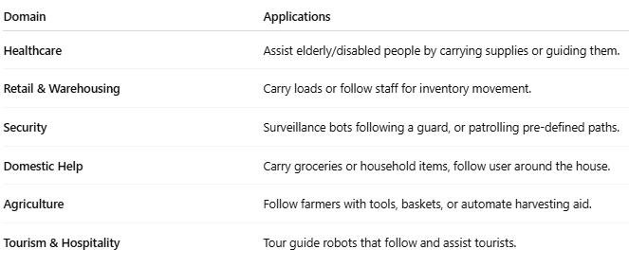

How to Modify & Improve It for Real-World Use
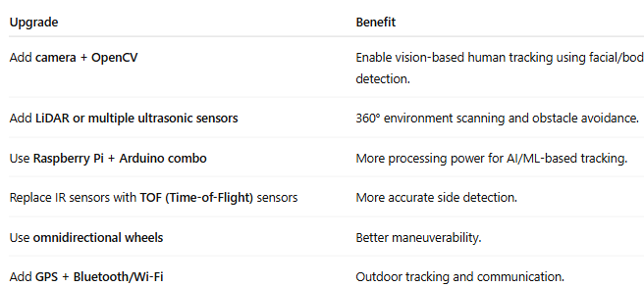
- Add a mobile app for manual override or remote control.
- Use RFID or QR code recognition for path and person identification.

Real-World Problem Solving Examples
1. Helping the Elderly
- Modified to carry medicines or food and follow seniors around the house.
- Integrated with voice command for interaction.
2. Warehouse Automation
- Track a worker and carry heavy loads autonomously.
- Communicate with inventory systems via IoT.
3. Hospital Supplies Delivery
- Follow nurses to deliver tools or medications.
- Autonomous route selection for delivery across departments.
4. Shopping Assistance
- Follow a customer and carry bags/cart.
- Recommend products via a display or voice interaction.

Conclusion
The human-following robot you built is a basic prototype showcasing:
- Environment sensing
- Basic automation
- Intelligent mobility
It can be expanded dramatically by combining modern sensors, AI models, and real-world connectivity, making it a practical and impactful solution in multiple industries.

